LAB TEST-4

- Name:T.Sai Tanuj
- Ht.No:2403A52413
- Batch:15

SET-3
Q1.(DatabaseDesign&SQL)
a) Generate an AI-assisted ER diagram for an online food delivery platform.
b) Write SQL queries to fetch top-selling food items.

PROMPT: “Generate an ER diagram for an Online Food Delivery Platform containing entities such as Customer, Restaurant, MenuItem, Orders, OrderItems, DeliveryAgent, Payment with appropriate attributes and relationships.”

CODE:
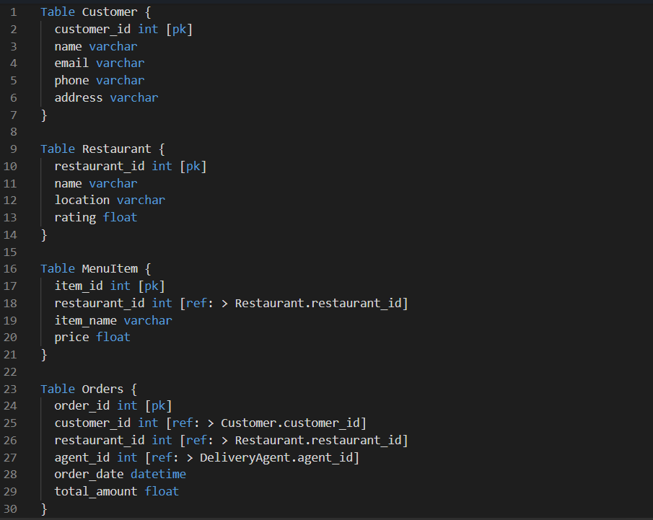

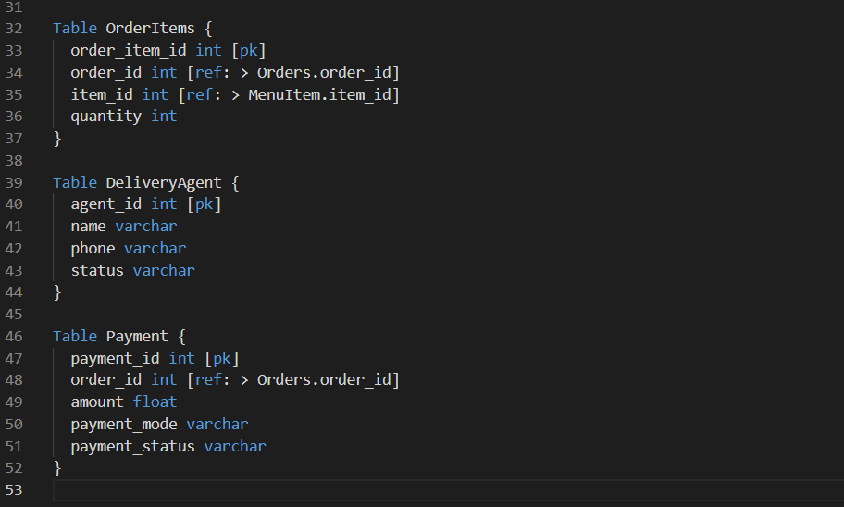

OUTPUT:

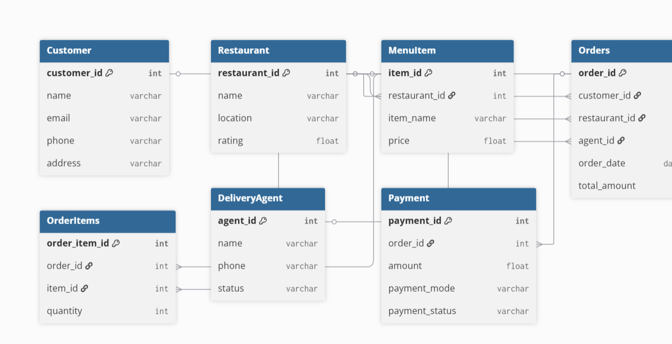

Observation:

The ER diagram clearly represents all key entities of an online food delivery system.
Relationships such as orders containing multiple items, each restaurant having many menu items, and each order assigned to a delivery agent are included.
This structure supports real-world operations like placing orders, tracking delivery, and managing payments.

------------------------------------------------------------------------------------

b) Write SQL queries to fetch top-selling food items.

PROMPT: “Write an SQL query to find the top-selling food items based on quantity ordered from the OrderItems table, joining with MenuItem to display the item name.”

Code:
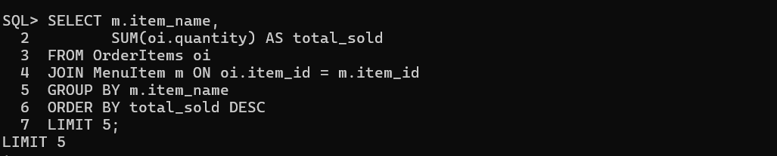

OUTPUT: 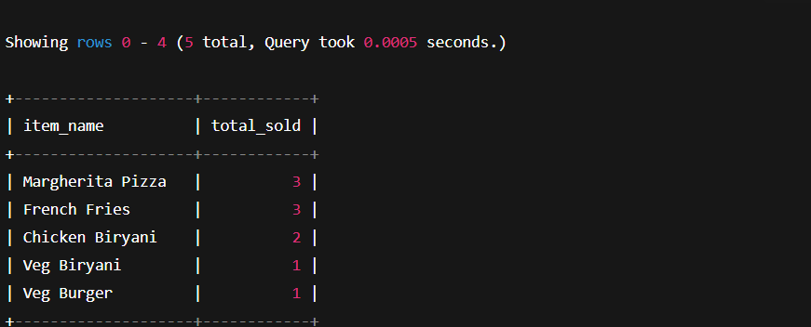

Observation:
The query correctly identifies the top-selling items by summing the total quantity ordered from all order records. Joining with the MenuItem table ensures item names are displayed. Sorting in descending order gives the most popular items first.

------------------------------------------------------------------------------------

Q2. (AI for Data Processing)
a) Clean a dataset containing restaurant reviews using AI-generated Python code

PROMPT: “Generate Python code using pandas to clean a dataset of restaurant reviews by removing null values, duplicates, special characters, converting text to lowercase, removing stopwords, and producing a cleaned dataset.”

Code:
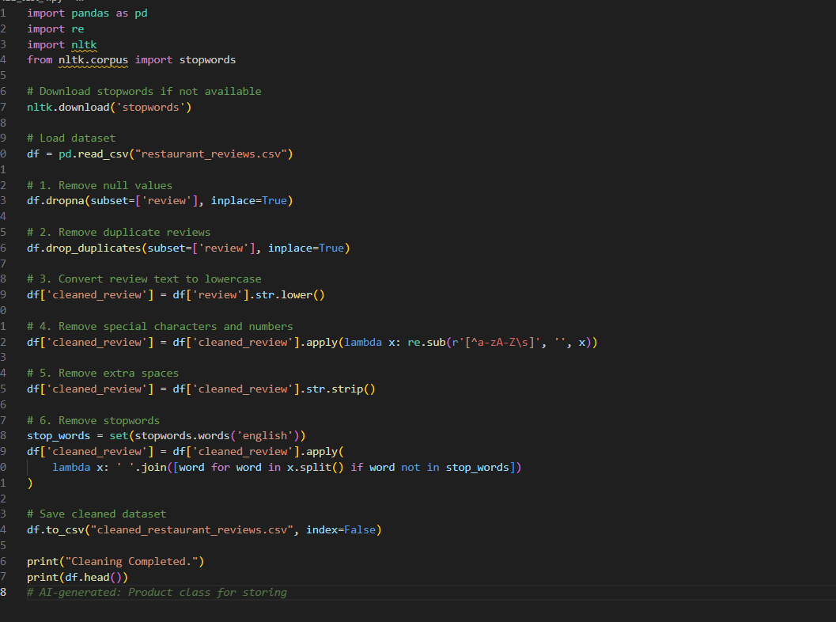

OUTPUT:

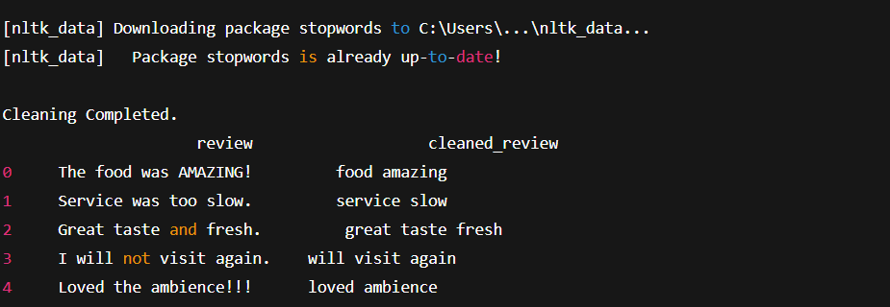

Observation:
The AI-generated Python code successfully cleans the restaurant review dataset by:
Removing null and duplicate entries
Converting text to lowercase
Removing special characters and numbers
Eliminating unnecessary spaces
Removing English stopwords (e.g., “the”, “is”, “and”)
Saving the cleaned data into a new CSV file

------------------------------------------------------------------------------------

b) Perform tokenization and stopword removal

PROMPT: “Generate Python code to tokenize restaurant reviews and remove stopwords using NLTK.”

CODE:
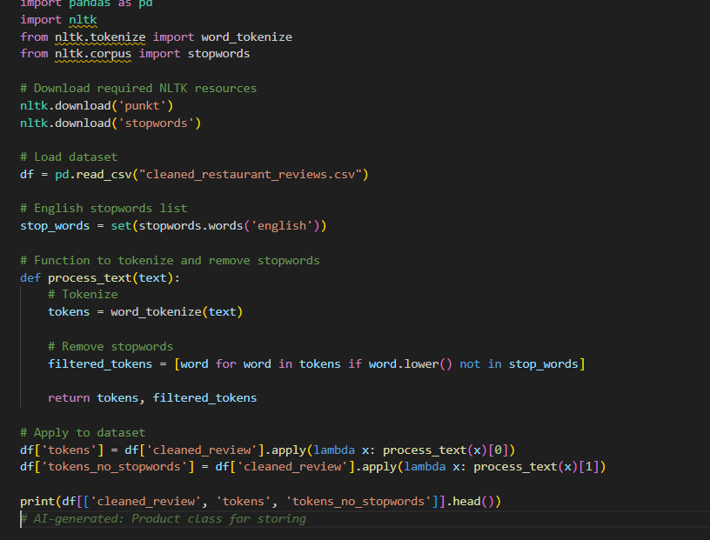

OUTPUT:

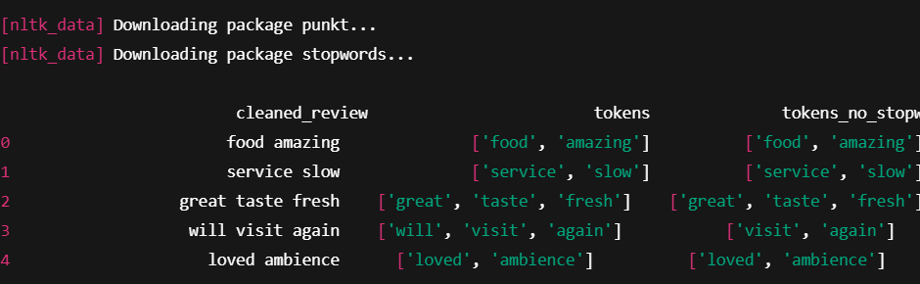

Observation:

This AI-generated Python code correctly performs:
Tokenization
Breaks each review into individual words (tokens).
Example:
"great taste fresh" → ['great', 'taste', 'fresh'].
Stopword Removal
Removes commonly used English words that do not carry meaning.
Example:
['will', 'visit', 'again'] → removes will → ['visit', 'again'].
Creates two new columns:
- tokens → tokenized words
- tokens_no_stopwords → meaningful words only
This prepares the text data for NLP tasks such as sentiment analysis or classificatio

